**Performance Metrics**

The Following table can be followed by error analysis for PSO feature extraction model. In this table contains mean absolute Error details are shows,

## Table 8.1.1 Mean Absolute Error

|  |  |
| --- | --- |
| Classification Algorithm | Mean Absolute Error |
| J.48 | 0.507 |
| MLP | 0.703 |
| SVM | 0.712 |
| Random Forest | 0.604 |
| Bayesnet | 0.572 |

Mean Absolute Error (MAE):

MAE measures the average magnitude of the errors in a set of predictions, without considering their direction. It’s the average over the test sample of the absolute differences between prediction and actual observation where all individual differences have equal weight.

## MAE = 1/n ∑ |yj- y^j|

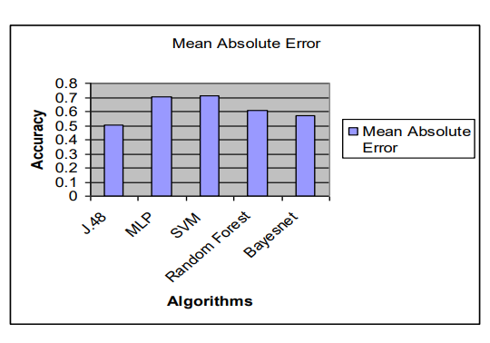

Fig 8.1.1 Mean Absolute Error Rate

The following table and figure describe a Root Mean Square Error (RMSE) analysis for PSO feature extraction model. In this table contains Root Mean Square Error details are shows,

## Table 8.2.1 Root Mean Square Error

|  |  |
| --- | --- |
| Classification Algorithm | Root Mean Square Error |
| J.48 | 0.487 |
| MLP | 0.403 |
| SVM | 0.425 |
| Random Forest | 0.467 |
| Bayesnet | 0.406 |

Root Mean Square Error (RMSE) is the standard deviation of the residuals (prediction errors). Residuals are a measure of how far liver dataset from the regression line data points.

RMSE is a measure of spread out these residuals is liver dataset.

RMSE = √ (f-o) 2

f = forecasts (expected values or unknown results), o = observed values (known results).

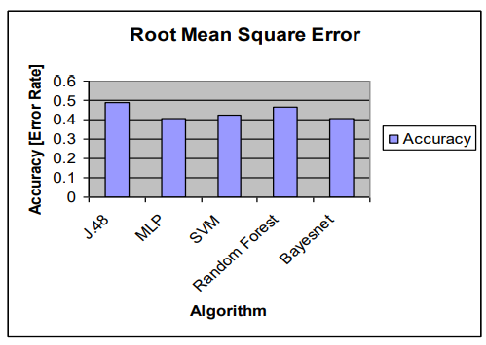

## Fig 8.2.1 Root Mean Square Error

The following table and Figure describe a relative squared error analysis for PSO feature extraction model. In

this table contains relative squared error details are shows,

## Table 8.3.1 Relative Squared Error

|  |  |
| --- | --- |
| Classification Algorithm | Relative Squared Error |
| J.48 | 73.33 |
| MLP | 69.23 |
| SVM | 71.45 |
| Random Forest | 68.44 |
| Bayesnet | 74.25 |

The root relative squared error is relative to what it would have been if a simple liver disease predictor and just the average of the actual values. Thus, the relative squared error takes the total squared error and normalizes it by dividing by the total squared error of the simple predictor. By taking the square root of the relative squared error one reduces the error to the same dimensions as the quantity being predicted.

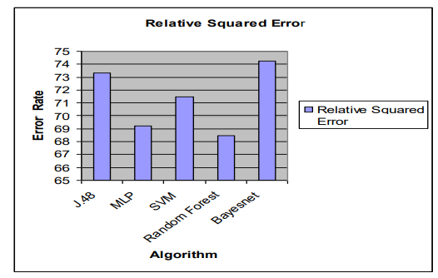

## Fig 8.3.1 Relative Squared Error

Mathematically, the root relative squared error Ti of an individual program j is evaluated by the equation. Where P(ij) is the value predicted by the individual program i for sample case j (out of n sample cases); Tj is the target value for sample case j; andis given by the formula:

## RRSE = Tj= 1/n ∑ j-1 Tj

The following table describes an overall classification algorithm for accuracy values analysis. In this table contains

existing and proposed accuracy a values shows,

Accuracy = (TP + TN) / (TP + TN + FP + FN)

|  |  |  |
| --- | --- | --- |
| Classification Algorithm | Greedy Step Wise | PSO |
| J.48 | 68.77 | 95.04 |
| MLP | 68.26 | 77.54 |
| SVM | 71.35 | 73.44 |
| Random Forest | 70.32 | 80.22 |
| Bayesnet | 67.23 | 90.33 |

The following Figure describes an overall classification algorithm for accuracy values analysis. In this fig contains

existing and proposed accuracy a values shows,

